BUKTI KORESPONDENSI JURNAL
Judul | The Quality Of Digital Literation Early Childhood Education Teachers Based On Unesco Standards
ID ARTIKEL | IJSTR-0320-31683
Penulis | Abna Hidayati, Raimon Efendi, Andra Saputra

No | Bukti
1 | Submit Paper  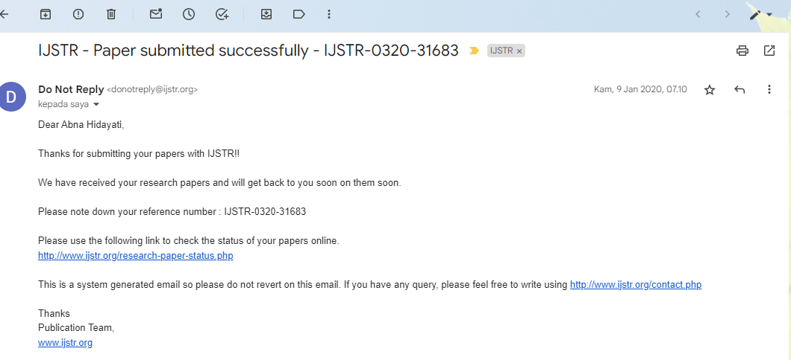
2 | 